Part 3:
A. conv() — Time-domain FIR filtering
Syntax:
$$y = conv(x,h)$$
Input Arguments:
x = input signal
h = impulse response / filter coefficients

Output Arguments:
y = filtered output signal

Example:
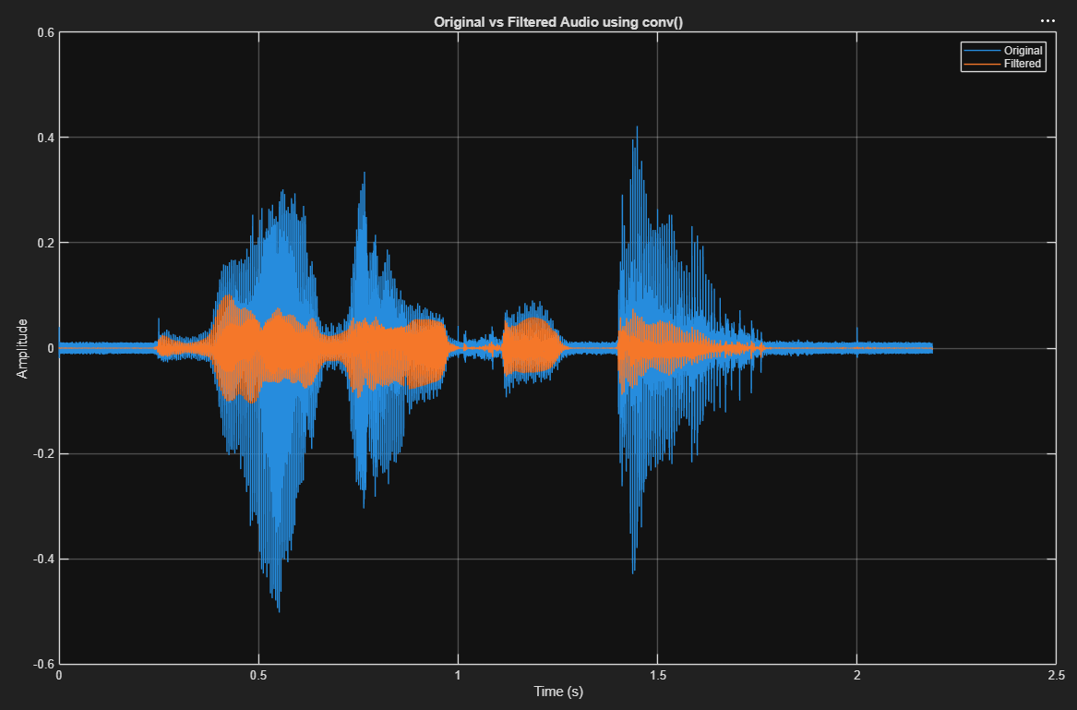

B. freqz() — Frequency response of FIR/IIR filter
Syntax:
$$[H,w] = freqz(b,a,N)$$
or
$$[H,F] = freqz(b,a,N,Fs)$$

Input Arguments:
b = numerator coefficients
a = denominator coefficients
N = number of frequency samples
Fs = sampling frequency in Hz

Output Arguments:
H = frequency response
w = angular frequency vector
F = physical frequency vector in Hz
Example:
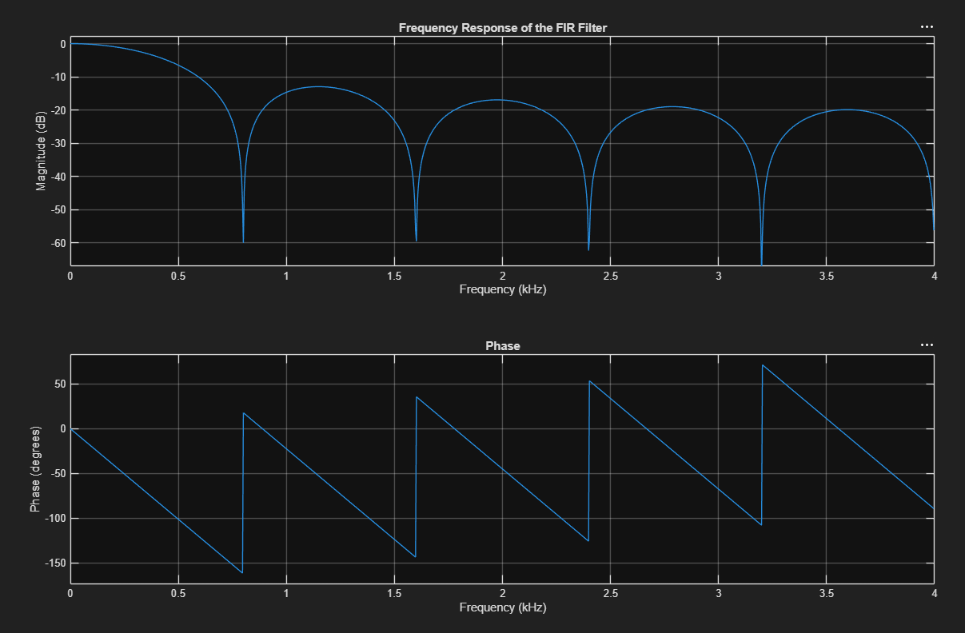
C. filter() — Apply FIR/IIR filter to signal
Syntax:
$$y = filter(b, a, x)$$
or
$$[y, zf] = filter(b, a, x)$$
Input Arguments:
b = numerator coefficients / feedforward coefficients
a = denominator coefficients / feedback coefficients
x = input signal
For FIR filter: $a = 1$
For IIR filter: $a ≠ 1$

Output Arguments:
y = filtered output signal
zf = final filter conditions, optional output

Example FIR:
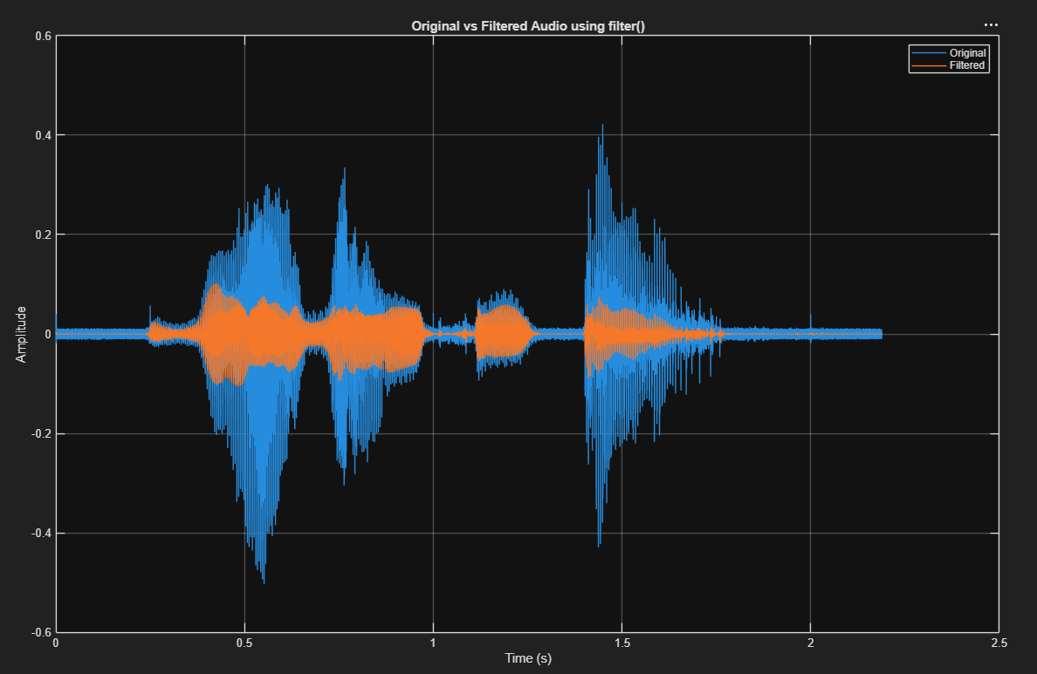

Example IIR:
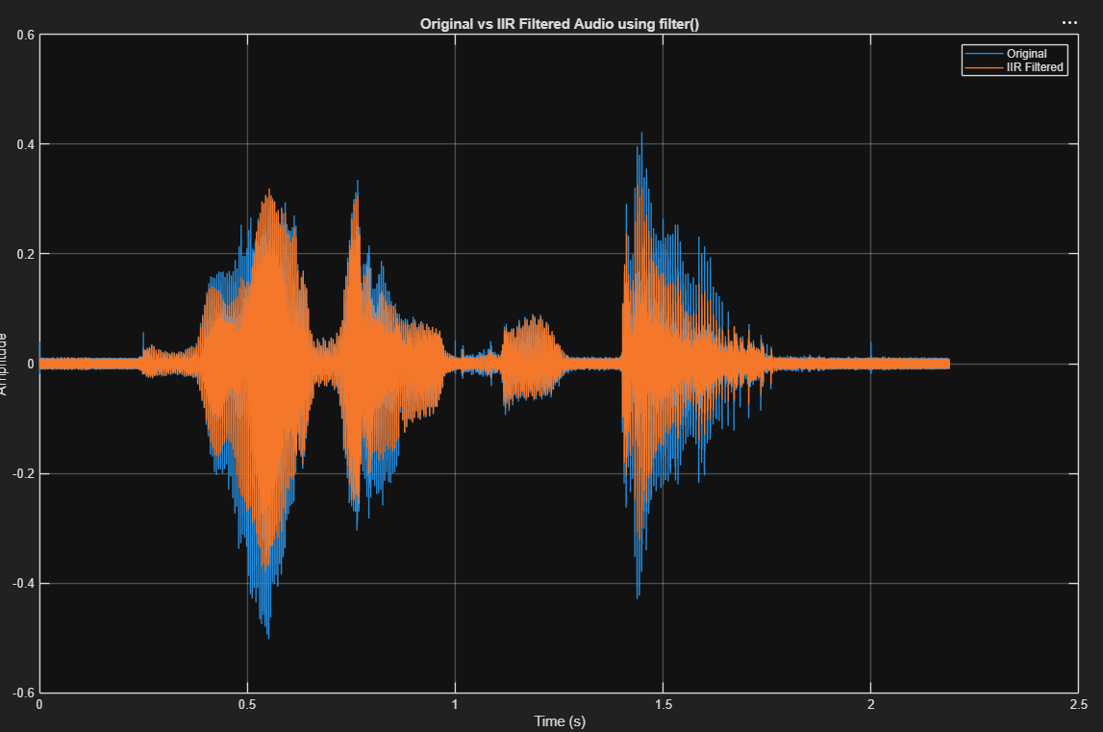

D. Output Arguments
• For conv(), the output y is the filtered signal produced by convolving the input signal x with the FIR impulse response h.
• For freqz(), H is the frequency response of the filter. The vector w gives angular frequency, while F gives physical frequency in Hz when Fs is included.
• For filter(), y is the filtered output signal. The optional output zf gives the final filter conditions, which can be used if filtering is continued in another segment.
• The filtered output can be plotted together with the original signal to observe the changes before and after FIR/IIR filtering.

E. Usage
• To filter an ECG signal, the raw ECG is treated as the input signal x[n], and the selected FIR or IIR filter is applied to produce a cleaner output y[n].
• conv(x,h) is used for FIR filtering, where the input ECG signal is convolved with the impulse response h[n] of the filter.
• filter(b,a,x) is used to apply both FIR and IIR filters. For FIR filters, a = 1. For IIR filters, a contains feedback coefficients.
• freqz(b,a,N,Fs) is used to check the filter frequency response, so we can see which frequency components are passed or attenuated.
• In an ECG filtering problem, these functions can reduce unwanted components such as high-frequency noise, baseline drift, or interference, while preserving the important ECG waveform.
• The original ECG and filtered ECG can be compared in the time domain to show that the filtering process makes the signal clearer for analysis.

